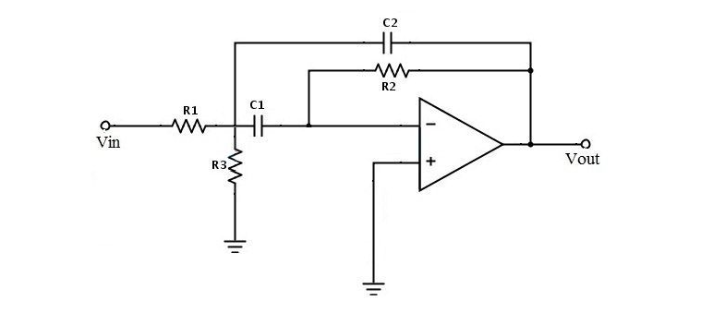

f = 10 k

Q = 5

Ku = 2

fmax – fmin = f/Q = 2k,

Полоса пропускания: 9-11k

Возьмем C1=C2=C=4.7n

w= 2\*Pi\*f = 62800

R1 = Q/(Ku\*w\*C) = 8468 =8.2k

R2 = Q/((2Q^2 – Ku)\*w\*C) = 352 =360

R3 = 2Q/(w\*C) = 33878 = 33k